**Environment Setup**

**Docker Account Creation**

|  |  |
| --- | --- |
| **Team id** | **PNT2022TMID49760** |
| **Project Name** | **Personal Expense Tracker** |

**Shunmugapavithra B**

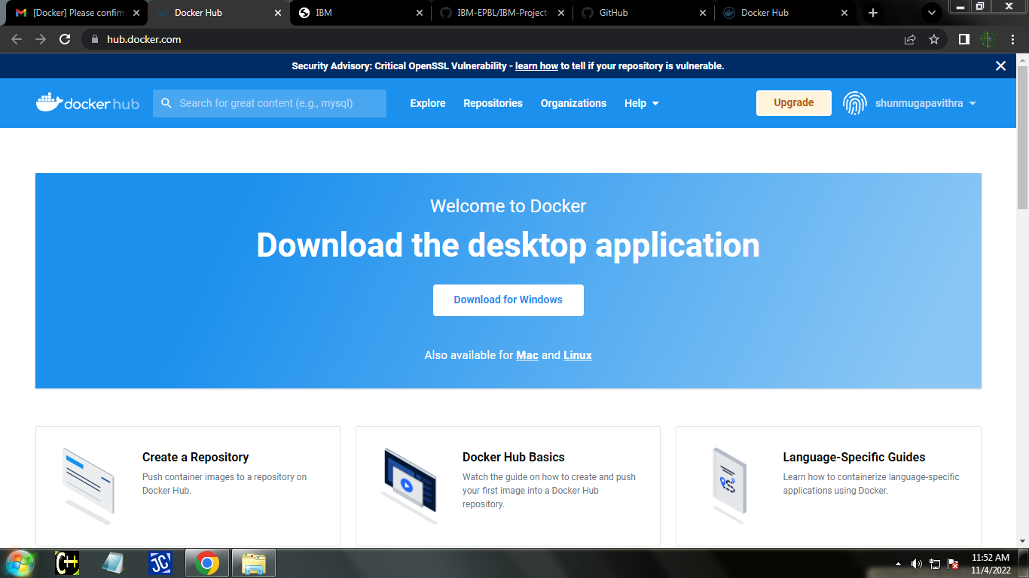

**Sharon Renisha**

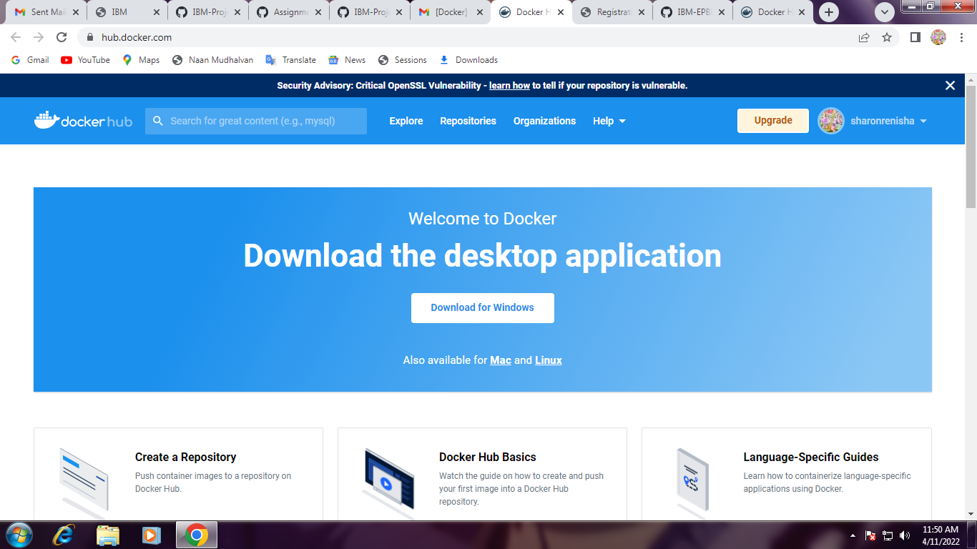

**Siva Sakthi**

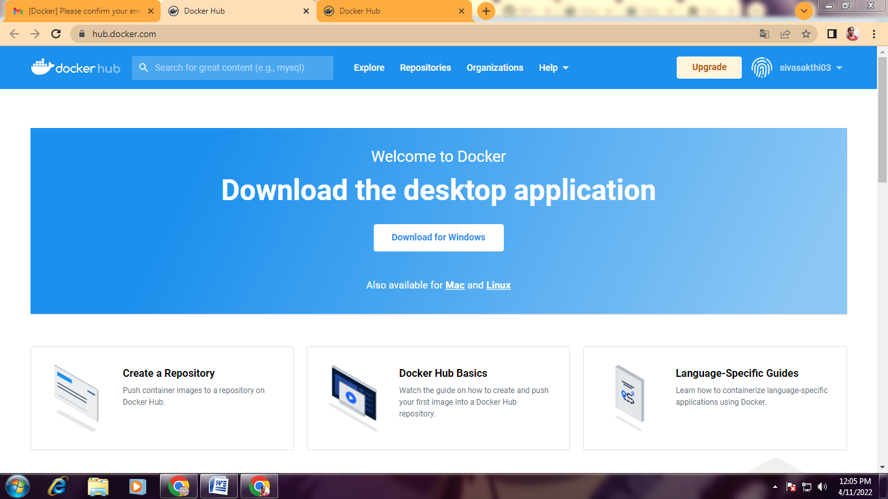

**Priya Dharshini**

